Jan. 2021
How to enroll the RIJYEM Insurance Plan
Illustration of procedure

1) Visit to the home page of RIJYEC

RIJYEC URL: https://rijyec.org/

Please Find out a button, and Click !!
Starting your Exchange program.

2) Find out and Click a button of ENROLL ONLINE

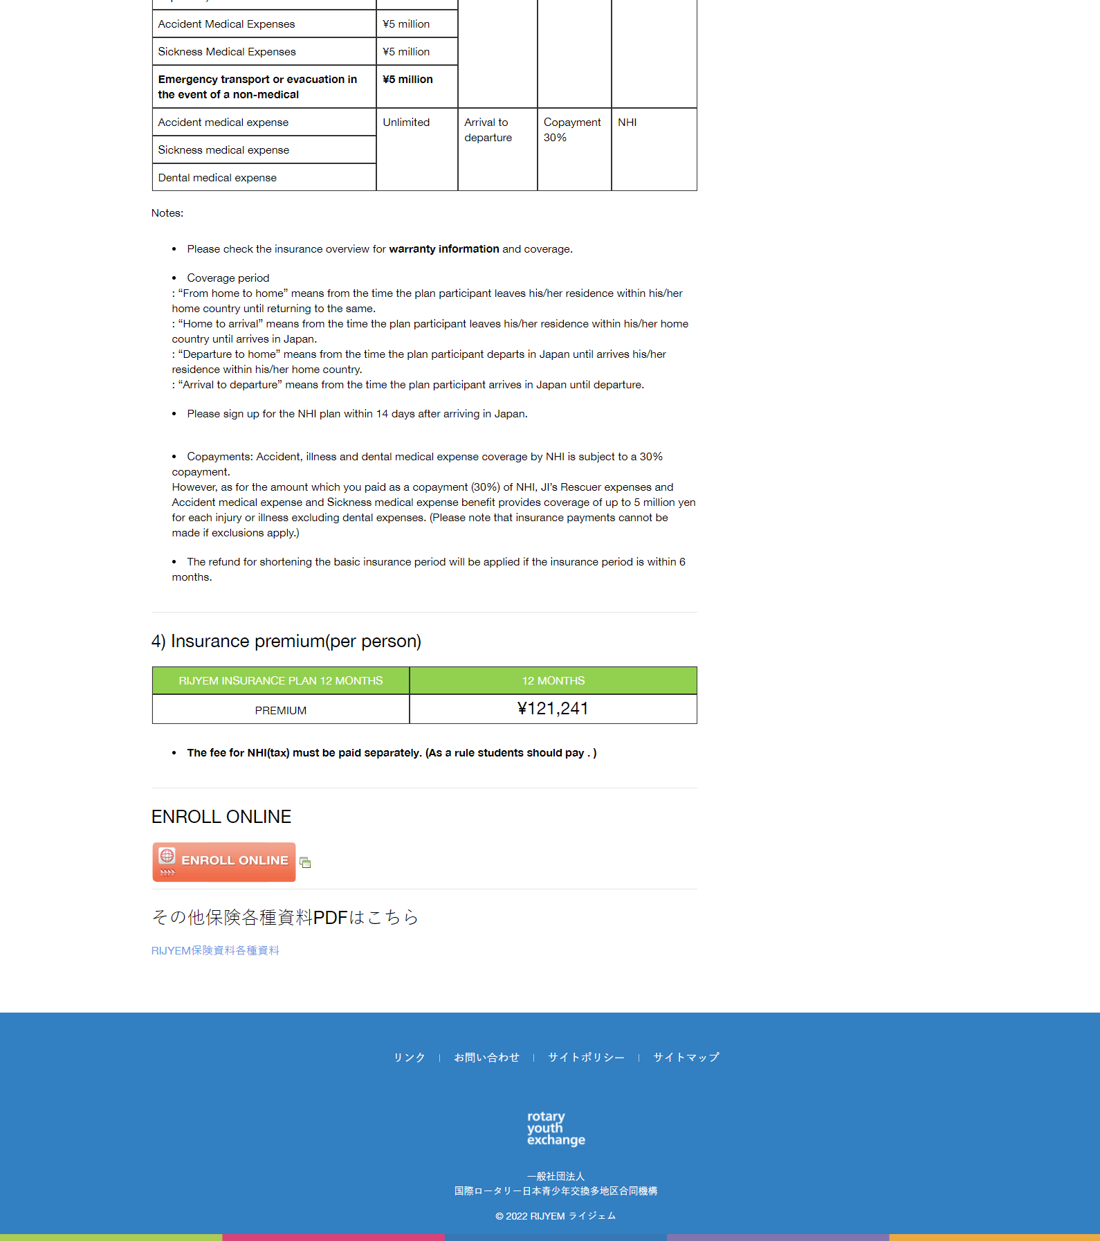
赤枠内部の英文を、新しいVer.3.1.1に変更する。

\121,241

Please Find out a button,
and Click !!

Please Find out a button,
and Click !!

3) RIJYEC insurance plan ONLINE ENROLLMENT System

Input your e-mail address.

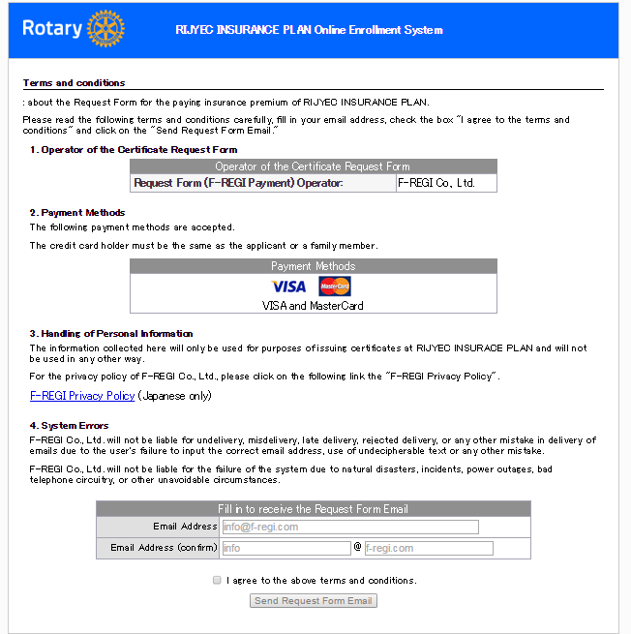
Input your e-mail address.

4) Information about the Request Form URL

Visit the LINK.

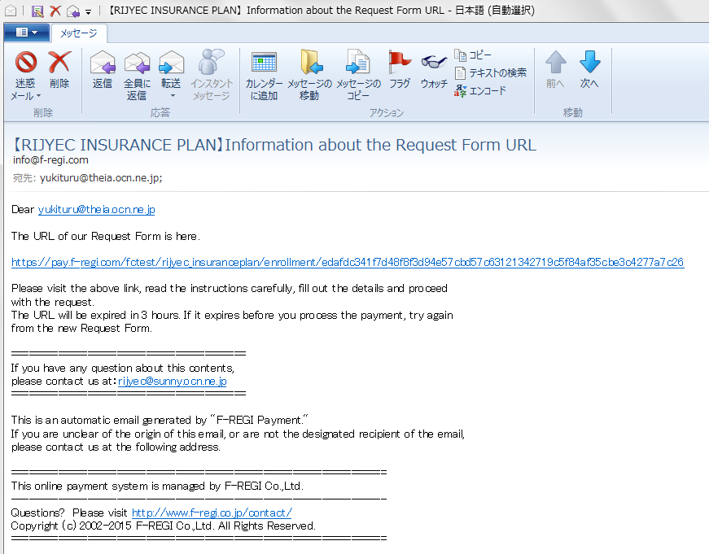
SAMPLE
Visit the Link

5) Fill in your information of STUDENT and credit information of CARDHOLDER.

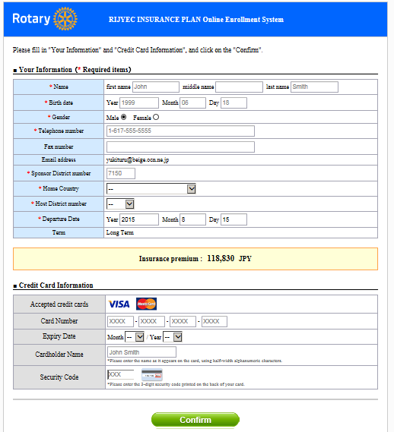
Student DATA
Cardholder DATA

121,241 JPY

6) Payment was completed

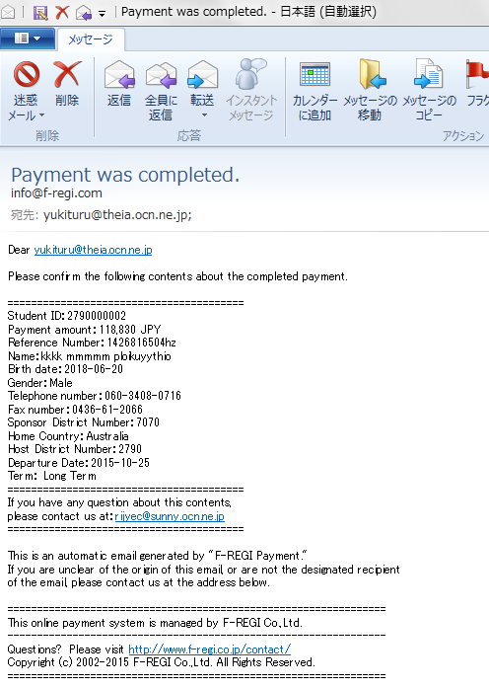
SAMPLE

